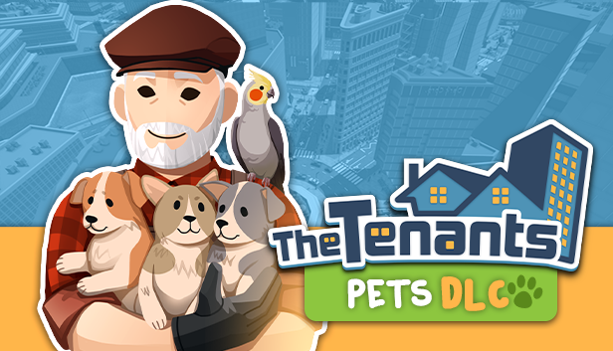

WELCOME TO THE PETS EXPANSION: THE TENANTS UNLEASH THE CUTENESS WITH NEW DLC

Prepare to embark on a heartwarming journey filled with fur, feathers, and endless joy as The Tenants introduces its highly anticipated Pets DLC, set to launch on August 31 on Steam.

This expansion brings a new dimension to the widespread property management game, allowing players to create pet-friendly homes and cater to a diverse range of adorable animals.

Watch the Trailer!

ANIMAL LOVER'S DREAM COME TRUE

In the Pets DLC, players can expand their property empires by welcoming an array of lovable creatures, from dogs and cats to raccoons, mini pigs, parrots, and more. Not only will you be tasked with finding suitable homes for your human tenants, but you'll also have the unique opportunity to foster meaningful relationships between them and their beloved pets. Strengthen your bond by interacting with the pets, playing with them, and offering treats, all while ensuring your rental business prospers.

UNLEASH YOUR INNER DESIGNER

The expansion brings over 500 new pet-friendly items and furniture pieces, enabling players to customize apartments to accommodate their tenants' furry and feathered companions. With 4 new Elite Contracts to complete, players can showcase their expertise in creating ideal living spaces for pet owners. The journey doesn't stop there – embark on the mission of transforming an old animal shelter into a pet paradise where stray pets can find loving homes.

A PET LOVER'S PARADISE

The Tenants Pets DLC is a haven for pet lovers, offering dynamic pets including various breeds of dogs and cats, parrots, raccoons, and mini pigs. Additionally, static pets such as fish, hamsters, bunnies, frogs, and turtles add to the enchanting world players can create. The expansion features new gifts, services, and sabotage options related to pets, along with new pet-related furniture and events. A brand-new phone app for pet management will ensure your tenants' pets are well cared for.

SPECIAL MISSION AND SURPRISE PRIZE

The Pets DLC introduces a special mission named "Parrot Collector," where players can unlock a secret prize by accomplishing unique objectives within the game.

The Tenants Pets DLC promises an immersive experience that brings together the love for animals and the thrill of property management. Get ready to build your empire with a pet-friendly twist and witness the growth of your business as you cater to the needs of animal enthusiasts in the virtual world of Wondersville.

Are you interested in joining Uncle Steve in this one-of-a-kind world of providing and handling tenancy? Join us in The Tenants Discord community, follow us on Twitter and Facebook, and find out more information on our official website.

About Ancient Forge Studio:

Ancient Forge Studio is a video game development studio from Poland, founded in 2018 by Max Strzelecki and Dushan Chaciej. Led by experienced game developers with a strong passion for mechanics-heavy games, the studio specializes in premium PC games. The studio's core principle is to build games that the team themselves want to play, as showcased by the release of Glorious Companions in 2019 on Steam Early Access and now their new main title, The Tenants, developed in partnership with Frozen District.

About Frozen District:

Frozen District is a group of gamers - personalities full of passion for virtual entertainment—regular people who are still ready to pull some all-nighters playing their favorite titles. We know what gamers need, as we are a part of the gaming community, and through creating our projects, which we would play ourselves, we fulfill our ambitions.

At the same time, we all want to be the best at what we do, still trying to reach the peak of our performance by polishing our skills and seeking innovative solutions. That is why in our midst, you can find experts in programming, marketing, graphics, design, and many more. Our main priority is constant improvement and crafting all the valuable experience gathered this way into the uniqueness present in our current and upcoming titles.

