LIBERTE – FACTSHEET
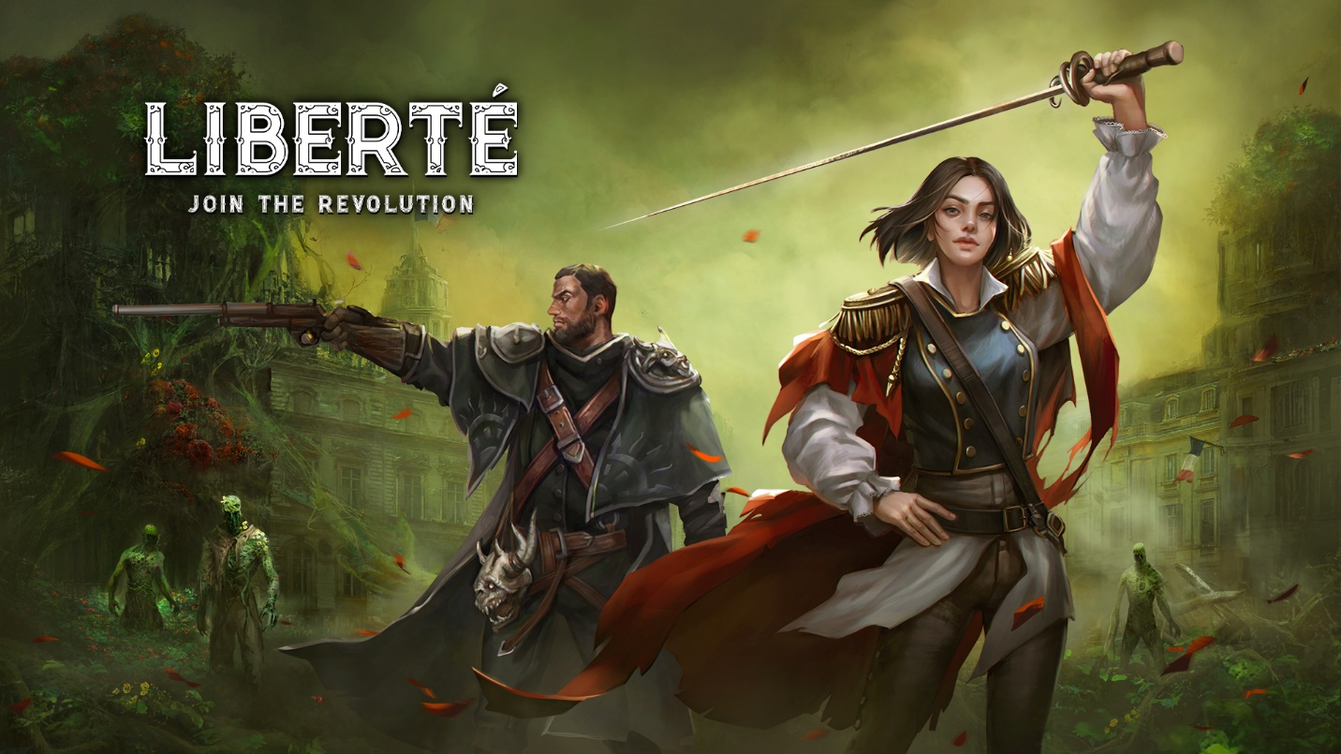

KEY FACTS
Title: Liberte
Developer / Publisher: Superstatic / Anshar Publishing
Platforms: PC
Genre: Rougelite
Tags: Rougelite, Hack and Slash, Deck-Building, Body Horror, Combat, Rougelike, Isometric, Action, Choices Matters, Alternative History,
Setting: High-Fantasy RPG
Release date: Early Access Launch – 15 Feb, 2022 | Full Release Q2 2023
Price: TBD
Useful links: Liberte on Steam, Liberte on GOG, WWW, Facebook, Twitter, Discord channel

Steam: https://store.steampowered.com/app/1159090/Zoria_Age_of_Shattering/
WWW: https://www.zoriagame.com
Facebook: https://www.facebook.com/ZoriaAgeOfShattering
Twitter: https://twitter.com/ZoriaGame
Discord: https://discord.gg/FEkvAJWw4a

ABOUT THE GAME
Liberté is a deck-builder roguelite set in Paris during the times of the French Revolution. Brave the war-torn streets as Rene - a regular Parisian entangled in a massive intrigue between the four most influential factions in the city. Collect cards, nurture alliances and discover the truth behind the city’s cryptic invader from another dimension, Lady Bliss.

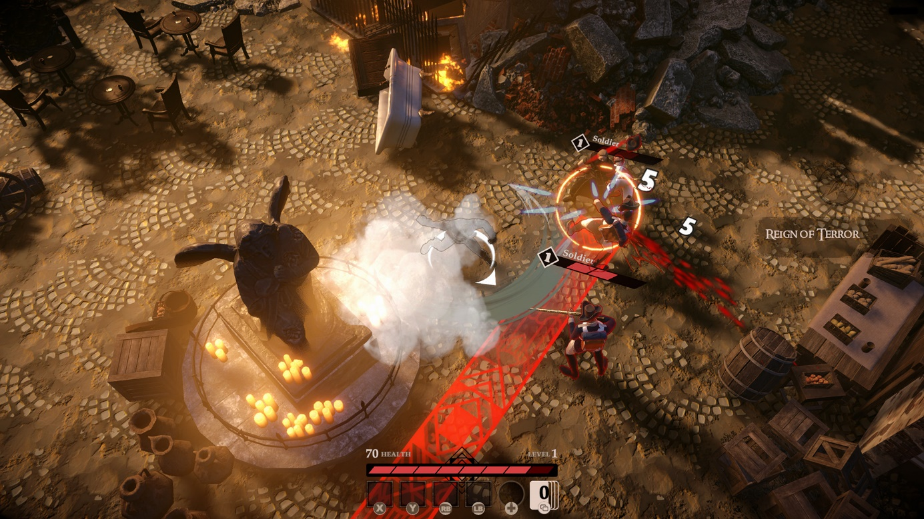

It’s the middle of a history-defining moment for 18th-century Paris. Without the king, with the crown missing, you wake up in a world ravaged by Lady Bliss - an otherworldly being that appeared out of nowhere during the coronation of Prince Phillip. Lady Bliss wants you to find her a worthy queen or king. Why, out of all the people in Paris, a grey citizen like Rene is destined to find the next ruler?
Build your unique playstyle with cards & skins

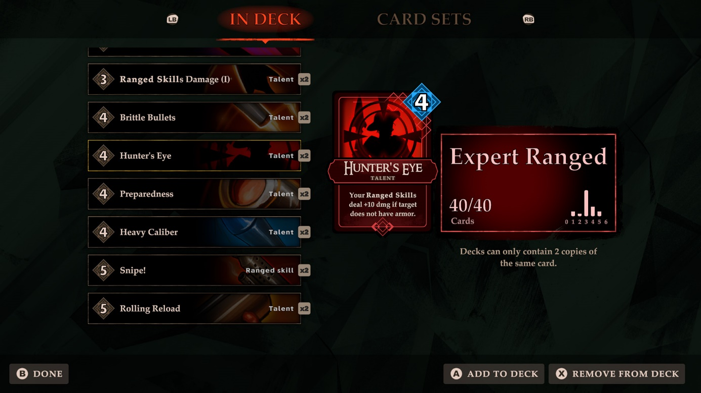
Mix and match from over 100 Skills and Talents cards. Go full-on guns-blazing, cut your way out with blades and axes, hit your enemies with a guitar, and sing the revolutionary song! Lead Rene in his human form or use the skin-shifter ability to play as one of the characters - Master Hunter Victor, Tribal Warrior Flea, or Revolt Leader Ana. You’ll encounter mighty enemies too, and face the curses of the Bliss, so make sure to come to the battlefield prepared.
Unravel the horrifying mystery of the Bliss
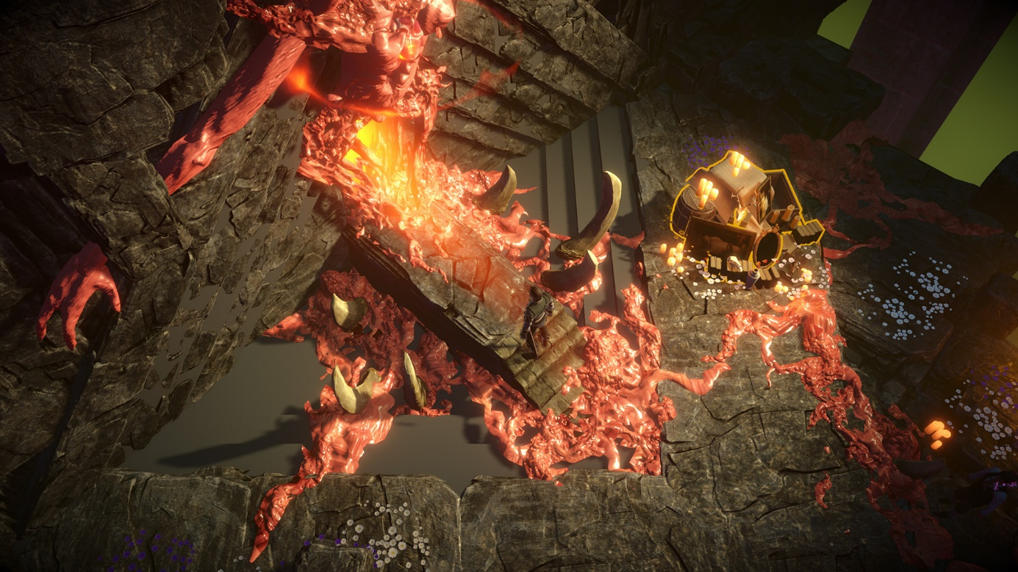
Lady Bliss came out of nowhere and nestled hidden in the Bliss - a Cronenbergian netherworld that only you can access. Guarded by the all-mighty Eldritches, the gardens of the Bliss are dangerous places. But as you do the monster’s bidding, you will uncover the mystery of who Lady Bliss is and why she chose you for her secret mission.
Immerse yourself in over 40 hours of dialogues
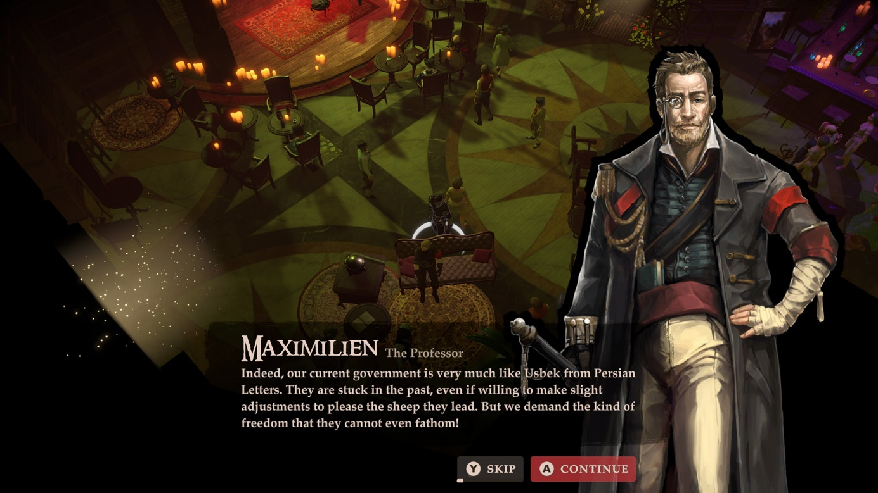
Inspired by the real French Revolution events, characters, and architecture, Liberté pulls you into a world on the brink of annihilation. Over more than 40 hours of gameplay, you will witness body horrors, participate in political maneuvers, and attempted assassinations, and see Madam Guillotine leaving a trail of blood.

ASSETS
All promo materials are available at this link: https://1drv.ms/u/s!AjqtyACv3eKUwG14fU-7ycDet_TN?e=vxPlnG

MEDIA CONTACT
Anshar Publishing
Mateusz Greloch – Publishing Manager
E-mail: mateusz.greloch@ansharpublishing.com
Twitter: @MateuszGreloch

General press inquiries related to other Anshar Publishing products: press@ansharpublishing.com

ABOUT SUPERSTATIC
We're a small team of passionate game developers, based in Poland. Liberte is our second published title.

ABOUT ANSHAR PUBLISHING
Anshar Publishing focuses on providing comprehensive marketing and publishing services for PC and console games.
We believe that marketing deserves craftsmanship and an individual approach to each project, based on the expertise of our team professionals. Created in 2021, the team consists of Anshar Studios veterans and experienced specialists who gained their understanding of the industry at key Polish game studios. Apart from experience, we are a group of passionate gamers with an openness to support independent developers and increase the visibility of their hidden gems. We are ready to be challenged and pave the way to your target audience.
More info at: http://www.ansharpublishing.com

