25 DAYS, 25 SURPRISES! MINDSCAPE RELEASES GAMES ADVENT CALENDAR FOR NINTENDO SWITCH AND STEAM, AVAILABLE NOW!

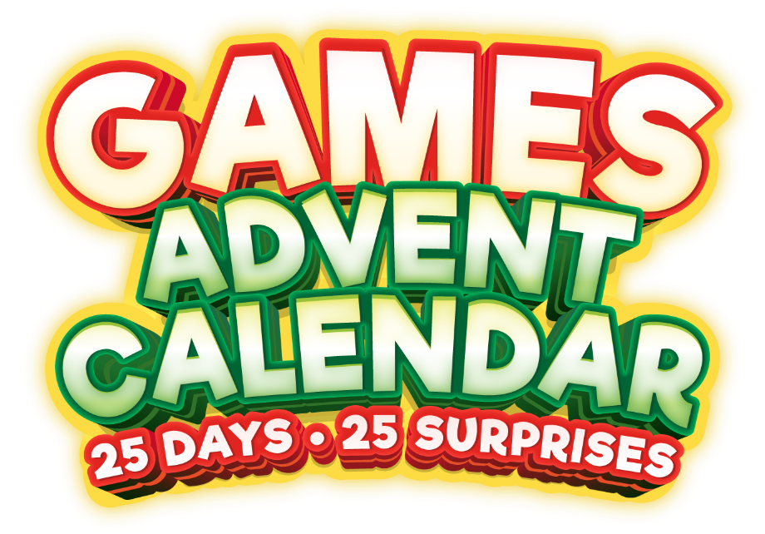

Mindscape is pleased to announce the launch of Games Advent Calendar. This unique advent calendar releases a brand new game daily from December 1 through Christmas, allowing gamers around the world to look forward to a month full of excitement and adventure.

Watch the trailer for Games Advent Calendar HERE.

ABOUT GAMES ADVENT CALENDAR:

With 25 different Christmas games - including Gift Runner, Holiday Jigsaw and Winterpong - it stays festive every day of December, and even after Christmas. Imagine every morning waking up during the holiday season and you get to open a new fantastic surprise. A surprise which you can play all day, every day. Grow your stack of presents with 25 different games, which all give you that special joyful Christmas cheer. You will hardly be able to sleep because tomorrow another surprise is waiting for you. The games are fun all year round!

Many of the games can be played with multiple players, allowing friends and family to fully enjoy the run-up to Christmas together. Mindscape looks forward to a festive month full of gaming and hopes that this Games Advent Calendar will take the holiday cheer to new heights. For more information and updates on the calendar, visit www.mindscape.com and follow us on [Social Media]. 25 Days, 25 surprises, 25 games! Countdown to Christmas and enjoy a new present every day!

Specifications:
- 25 DAYS, 25 SURPRISES, 25 GAMES! - Countdown to Christmas and enjoy a new present every day!
- ENJOY THE FULL CHRISTMAS EXPERIENCE - Your first surprise starts the 1st of December. Can’t wait? You will also have the option to unlock all presents immediately and start playing right away!
- GET IN THE FESTIVE SPIRIT - Step into the breathtaking scenery of a Winter Wonderland. Watch the beautiful lights, listen to the sounds and enjoy the scenery.
- FANTASTIC CHRISTMAS GAMES - Gift Runner, Arctic Adventure, Bauble Shooter, Penguin Runner, Holiday Jigsaw, TetriX-mas, Winterpong, Christmas Match 3, and many more surprises
- PLAY WITH FRIENDS AND FAMILY - 25 days full of challenging games, many of which you can play with multiple players for endless Christmas fun!
- INFINITE GAMING FUN - Don't just play during the holiday season, each game can be played every day, forever!

Games Advent Calendar is available now on Nintendo Switch and Steam. Also available in stores as a physical Code in a Box version for Nintendo Switch.

For any questions about the game please get in touch with Agnieszka Szóstak at agnieszka.szostak@pr-outreach.com or call +48 881 951 601.

Games Advent Calendar ©2023 Mindscape® and the Mindscape® Logo are registered trademarks of Elementalz B.V. and its affiliates. ©2023 All rights reserved.
© Denda Games © Graphium Studio

__________________________________________________________________________________
About Mindscape
Established in 1991, Mindscape has been at the forefront of development, marketing, publishing and distribution of video games for over 30 years. Capturing the minds and imagination of millions of gamers around the world, from children to adults. Mindscape is best known for Distributing big brands such as Asterix & Obelix, The Smurfs, Kena: Bridge of Spirits, Story of Seasons. Publishing games like Windstorm/Whisper, Speed 3: Grand Prix and Recompile. Developing products like Prince of Persia 3D, Myst, Riven, Reader Rabbit, Life in Willowdale: Farm Adventures, Advent Calendar, Super Puzzle Pack. In the coming years, Mindscape will bring more fun- and accessible games. For more information, visit www.mindscape.com. Mindscape® and the Mindscape® logo are registered trademarks of Elementalz B.V. and its affliates. © 2023 All rights reserved.

