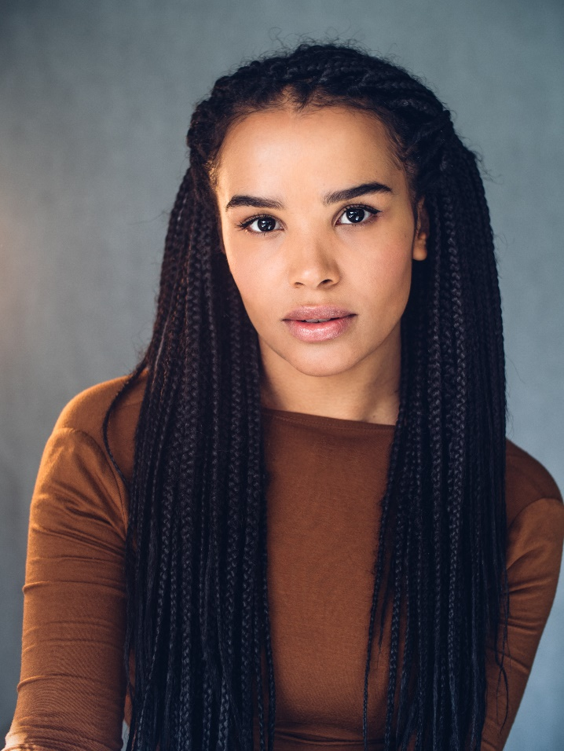

ZOË ROBINS – Q&A SESSION
ABOUT HER WORK ON EVIDENCE 111

- Q: What convinced you to take a part on this project?

A: I love storytelling and the concept of working in this way was new and exciting for me. I like how straightforward and accessible this game is too. I listened to parts of the Czech version for inspiration. The work is so specific as I was able to understand what was happening, without understanding the words being said!

- Q: Who is your character and is there anything you find interesting or relatable about her?

A: I play a character called Alice Wells, who is the player's guide through the audio game. I like Alice's curiosity of herself and others. I also admire her courage and persistence, which the audience will experience either a little or a lot depending on which route they choose to take.

- Q: How was it to perform for a non linear story? What was most difficult for you?

A: We worked out of sequence so the most challenging part I found was trying to navigate Alice's constantly changing emotions, thoughts and energy. As an actor you're often influenced by another person in close proximity to you, but as I was mainly performing alone I had to heavily rely on the script and my imagination. The whole team helped as well, so we were able to keep track of the moment.

- Q: Is there some part of the game / story that you really like?

A: There's a particular part in the story where Alice ends up outside and is having to battle with the elements. Working with the sounds of wind and rain was really fun. The highlight for me was when Rosamund and I were in the booth together. Rosamund brought such enthusiasm and life to the work, which I'm sure has translated into the scenes. It's a joy to work with her.

