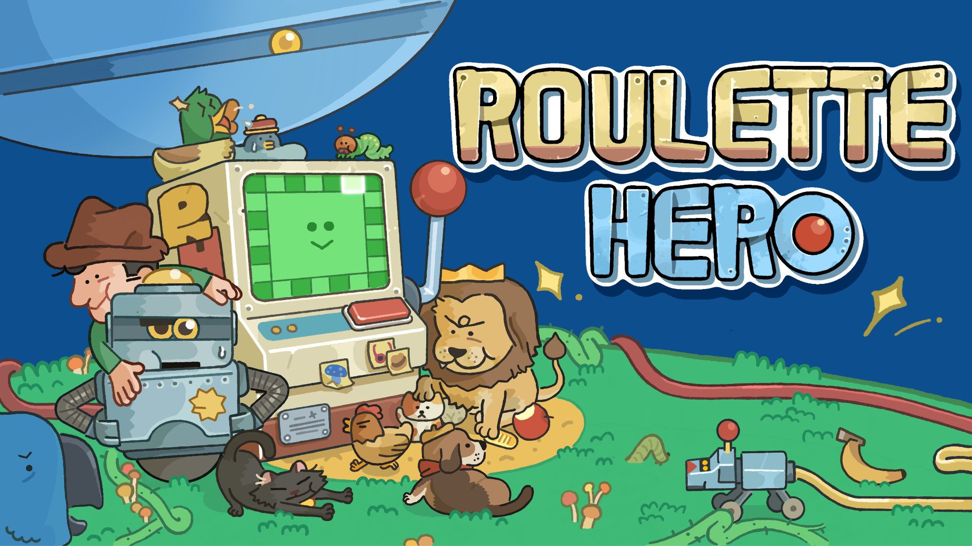

Spin, Strategize, Survive: Spiral Up Games Announces ‘Roulette Hero’
Assemble your Animals, Craft Insane Strategies, and Spin the Wheel!
Singapore, 24 April 2025 – Spiral Up Games is thrilled to unveil Roulette Hero, a one-of-a-kind strategic roguelike deckbuilder where your fate spins on a wheel. Developed by solo indie developer CLLC Studio, Roulette Hero blends autobattler mechanics with a roulette-inspired system that makes every battle unpredictable and deeply strategic.
Roulette Hero’s first public playtest will also be made available on its Steam store page, and players are invited to try the game out.
Watch the Official Playtest Trailer here: https://youtu.be/EF4ZyN48p9Y

Be sure to try the Roulette Hero playtest on Steam and tell us what you think!

Aldric Chang, CEO of Spiral Up Games shares: "As a publisher of high quality indie games, we are on the constant lookout for games that bring something different to the table. Roulette Hero combines the autobattler genre with roulette elements to give a fresh twist to the deckbuilder genre. The game’s countless combos and strategies provide great replayability.”

About Roulette Hero
In Roulette Hero, you assemble animal companions to defeat towering mechanical beasts. Build a team of unique animal companions—some strike fast, others defend with unbreakable resolve, and some are just too adorable to leave behind. Line up the perfect squad on your roulette wheel, spin to activate your animals' abilities, trigger game-changing synergies, and turn the tide of battle! Every spin could lead to an outrageous victory!
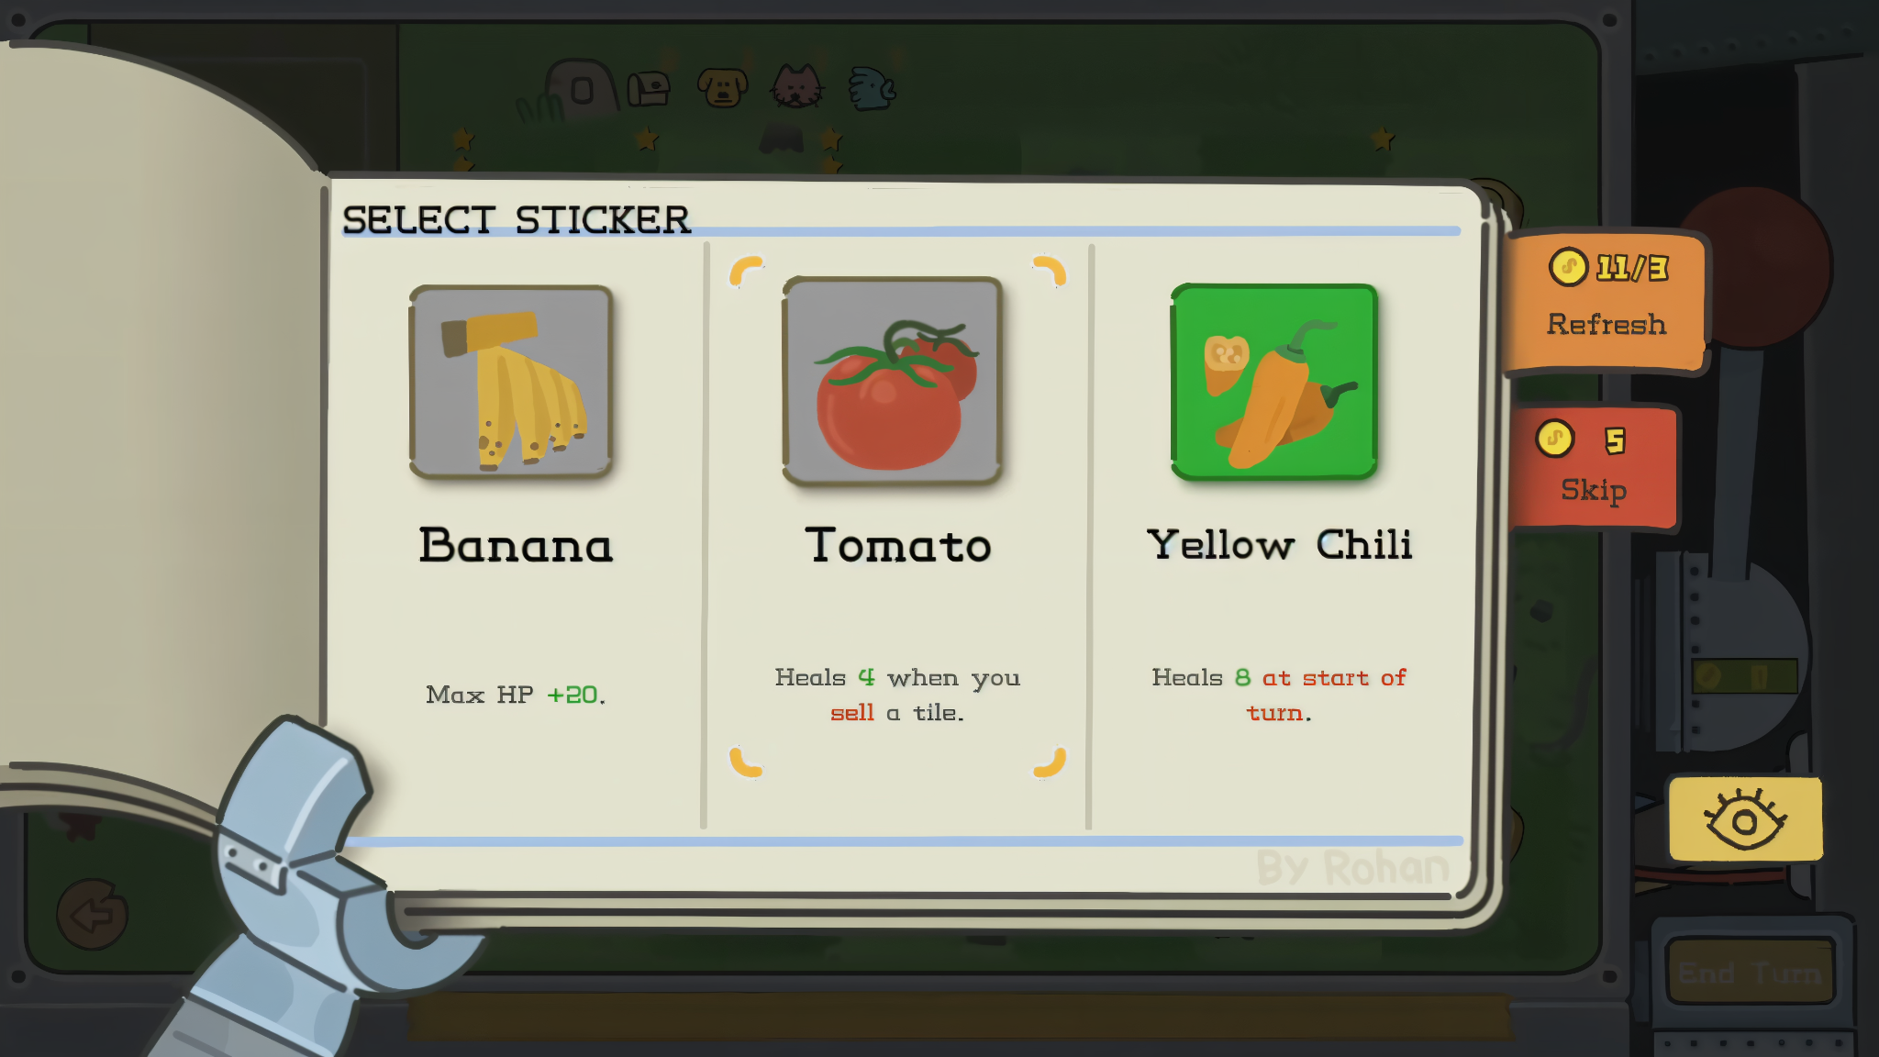
Key Features:
- Spin to win: Trigger devastating combos and over-the-top synergies with every roulette spin.
- Build your beast squad: 100+ animals across 13 species to mix and match. Unleash over 90 power-ups with them!
- Mod your madness: Steam Workshop and Creative Mode support included.
- Climb the ladder: Asynchronous multiplayer and global leaderboards.
- Constant evolution: New content in active development - help shape the journey!

About CLLC Studio
CLLC Studio is a solo game development studio based in Chengdu, China. Passionate about deep strategy and accessible design, the developer draws inspiration from deckbuilding games, Dota 2, Warhammer, and One Piece. Roulette Hero is their second deckbuilding project and aims to blend relaxation with tactical depth.

About Spiral Up Games
Spiral Up Games is an international game publisher for high quality PC indie games, headquartered in Singapore. Its team members comprise experienced game veterans with decades of combined experience in indie game development and marketing. Their mission is to find the hidden gems of the indie market and polish them into shining diamonds so that they can be enjoyed and celebrated by gamers worldwide. Visit http://www.spiralupgames.com for more information.

Press Release Assets:  - Screenshots  - GIFs | Social Links:  - Twitter  - Bluesky  - Tiktok

