GAMEDEC – DEFINITIVE EDITION – FACT SHEET
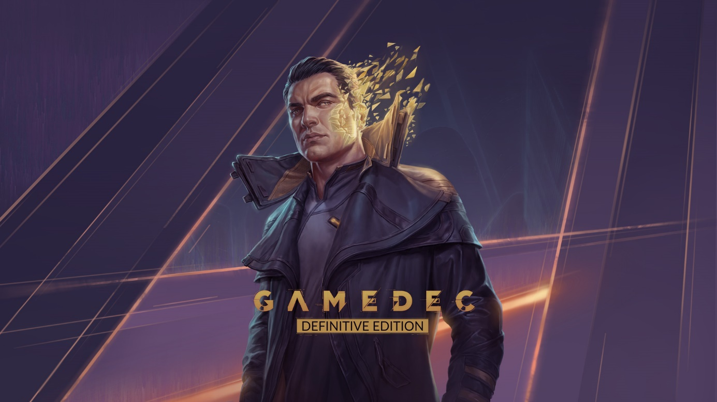
KEY FACTS
Title: Gamedec – Definitive Edition
Developer / Publisher: Anshar Studios
Platforms: PC, Nintendo Switch
Genre: Adaptive Cyberpunk RPG
Tags: Cyberpunk, RPG, Story Rich, Isometric, Futuristic, Detective, Investigation, Nonlinear, Multiple Endings, Choice Matter, Narration, Character Customization, CRPG, Adventure
Setting: Cyberpunk
Release date: September 29th, 2022
Steam: https://store.steampowered.com/app/917720/Gamedec/
GOG.COM: https://www.gog.com/game/gamedec
WWW: https://gamedec.com
Facebook: https://www.facebook.com/gamedecthegame/
Twitter: https://twitter.com/GamedecTheGame
You Tube: https://www.youtube.com/user/AnsharStudios
Discord: http://discord.gamedec.com/
ABOUT THE GAME
Gamedec – Definitive Edition is a single-player, non-combat, cyberpunk, isometric RPG. You are a gamedec – a private detective who solves crimes inside virtual worlds. The decisions you make will alter your character’s traits and impact the course of the game, but cases are riddled with dilemmas and rarely clear-cut.

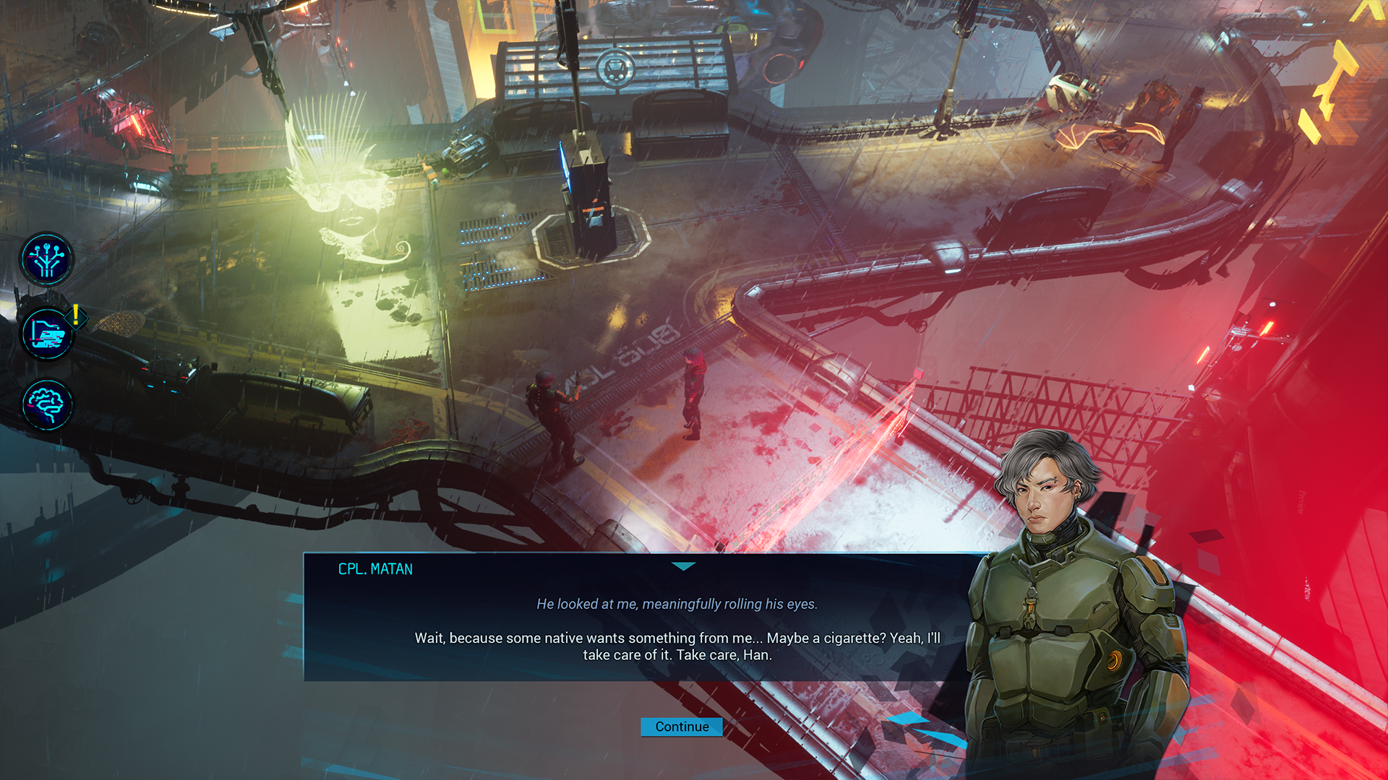

YOU ARE THE SUM OF YOUR CHOICES
Discover and expose intrigue – or enter into the schemes yourself. Save lives – or destroy them. Expose confidential relationships between the virtual worlds and their inhabitants. In Gamedec, there is no black and white – some options will feel right, while others might surprise you. What choices will you make, when faced with real dilemmas? Each decision you make will shape the game world and your character’s personality. The game never judges your actions – but can you live with your choices?

EXPLORE THE CYBERPUNK OF THE XXII CENTURY
In Warsaw City, the 22nd century is almost at an end. The world’s natural environment has mutated and become hostile to humanity, and humans are forced to live in cities fortified from an aggressive ecosystem outside. But in the fight for resources, the trapped population is divided into the ‘haves’ and ‘have-nots’. Many choose to escape into Virtualia – virtual games that enable them to forget the world’s horrors and fulfill their fantasies, however dark they may be.

EXPERIENCE THE ESSENCE OF ROLE-PLAYING
Gamedec is a pure RPG experience equipped with mechanics such as a codex, aspects, and deduction. Fight conversational duels, discover or build schemes of intrigue, save lives, and discover extraordinary relationships between the virtual worlds and their inhabitants. The game emulates the nature of a tabletop RPG by focusing on choice-dependent character building. Gamedec emulates the nature of a tabletop RPG by focusing on multiple, choice-dependent, character-building scenarios. You are the sum of your choices, and the game adapts to your playstyle.

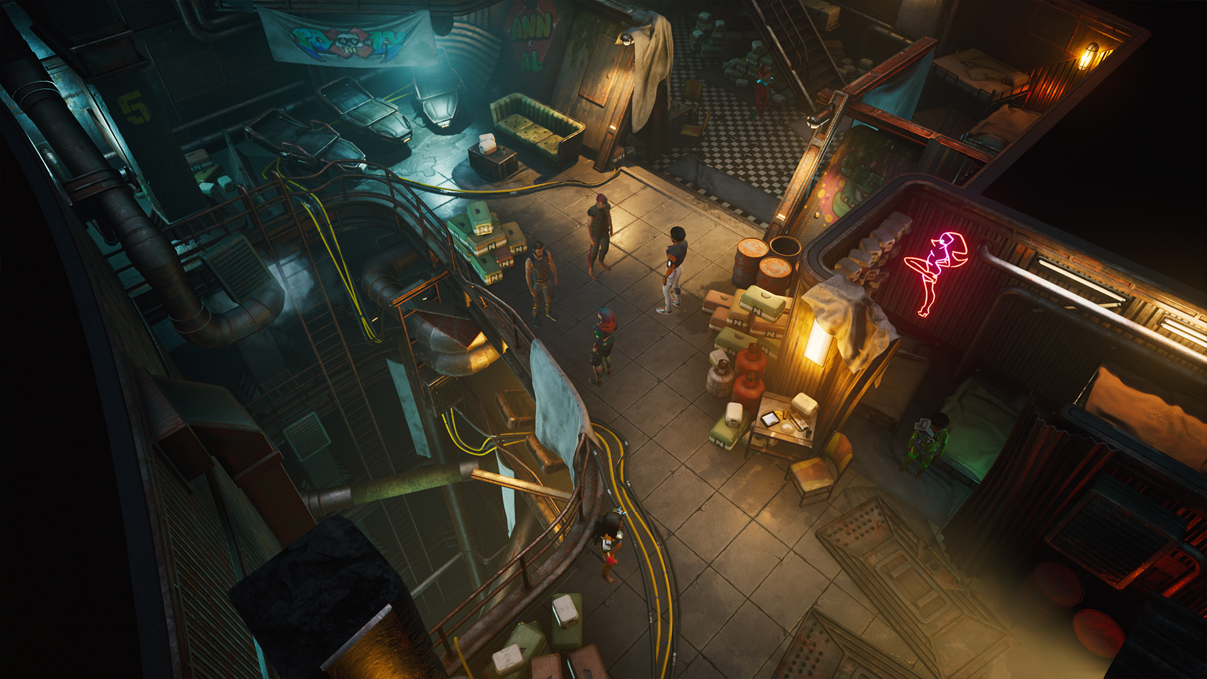

ASSETS
All promo materials are available at this link: https://pr-outreach.com/en/game/gamedec-definitive-edition,19.

MEDIA CONTACT
PR Outreach
Agnieszka Szóstak
E-mail: agnieszka.szostak@pr-outreach.com
Mobile: +48 881 951 601
Twitter: @aga_szostak

ABOUT ANSHAR STUDIOS
Craftmanship is our way. We follow the radical truthfulness philosophy to communicate and, as a result, bring impactful, first-party ideas to life and deliver third-party projects perfected. Skilled team, well-crafted portfolio, and ambition to grow. We’re hungry for making good games, so wait for Gamedec or let us help you create one for you.
Anshar Studios has also expanded the scope of their activities, and offers services to many reputable companies in the video game industry. Examples of these collaborations include Larian Studios, Bloober Team, Artifex Mundi, The Farm 51, Playway, and QLOC. The latest Anshar first-party projects were Telefrag VR – a fast-paced PVP VR shooter, and Detached – a space exploration VR game. The studio is also involved in the development of a few undisclosed projects for a group of premium tier customers.
More info at: http://www.ansharstudios.com

