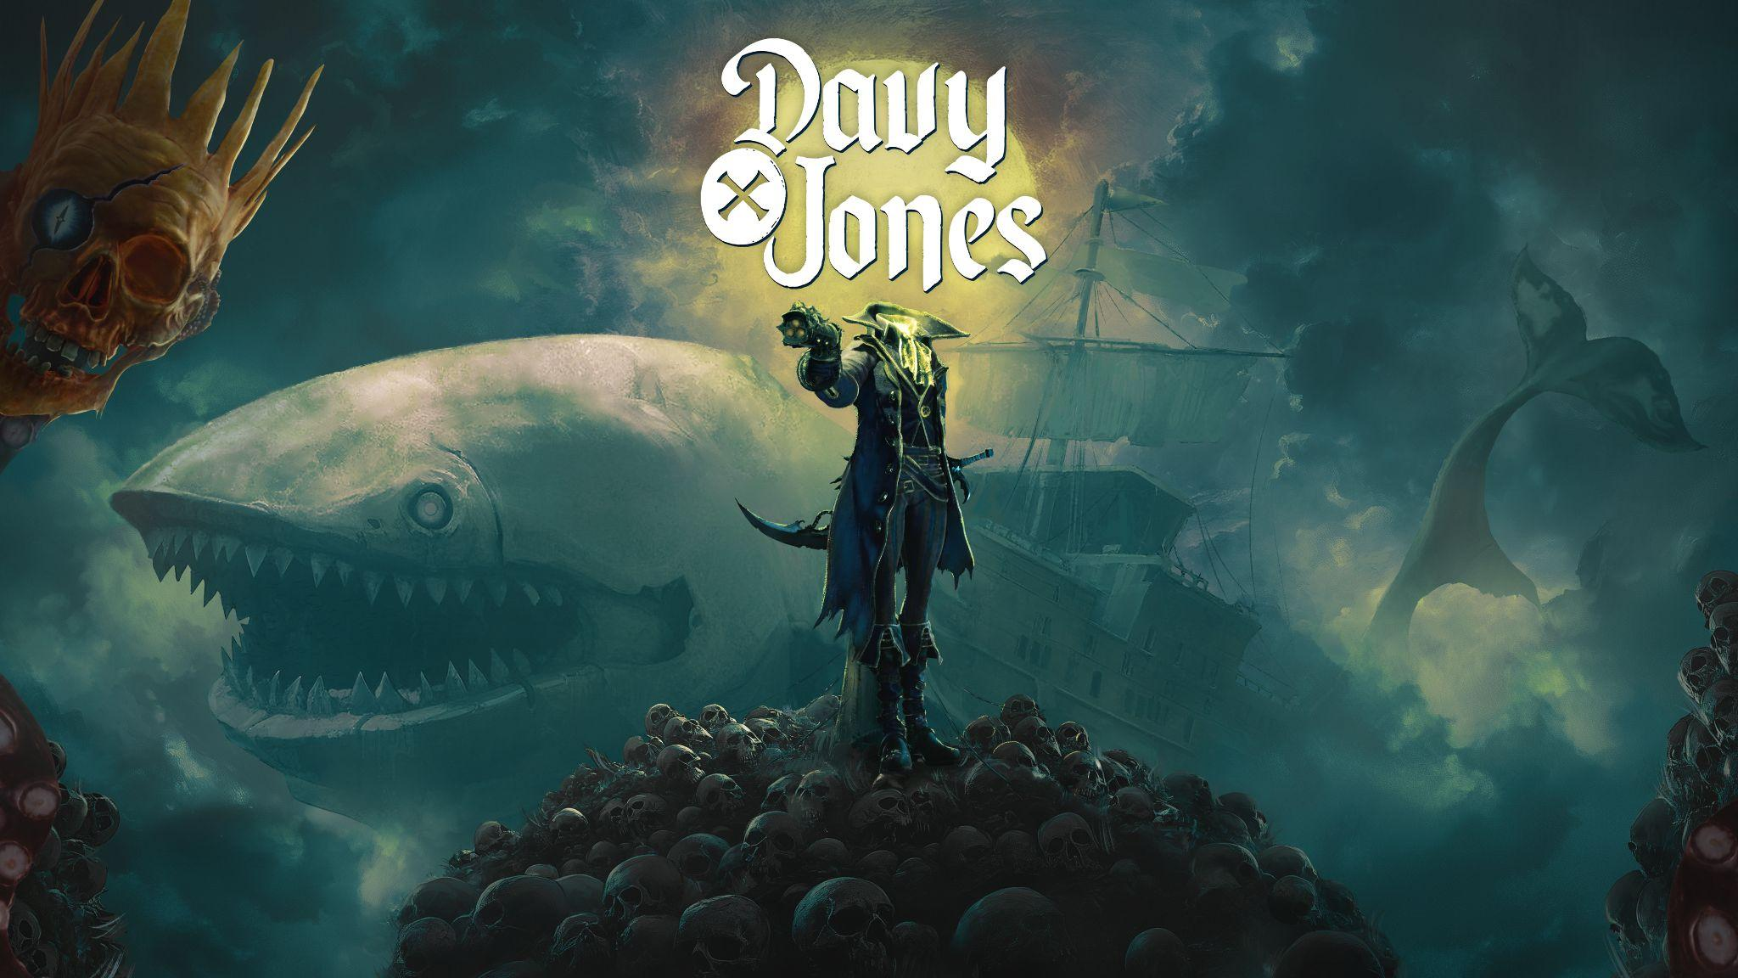
DAVY x JONES – “KRAKEN HUNT” MAJOR UPDATE NOW LIVE
Command the skies as Davy, lead roguelite Sky Hunts, and face the Kraken in PARASIGHT’s grand pirate action-adventure
Kraków, Poland – November, 25th – You thought you knew The Locker? Think again. PARASIGHT invites new and returning players to rediscover its grand pirate action-adventure DAVY x JONES, delivering the long-promised other half of the fantasy: command the skies as DAVY (HEAD) aboard Abby, a colossal living ship — half whale, half war machine — in evolving roguelite Sky Hunts that culminate in a showdown with the Kraken.
If you've only experienced the intensive first-person combat on the ground as JONES (BODY), you've only seen half the legend. With Kraken Hunt, the sky command layer comes live — give Orders, recruit Officers, and upgrade Abby as you carve power across the Sea of Clouds.
Watch the new ‘Kraken Hunt’ Update Trailer HERE.
This update empowers players to fully embrace the role of DAVY - the legendary captain’s skull. Players will now command their colossal living ship, Abby, in the skies. As Davy, you'll take the helm of your half-whale, half-war-machine vessel to navigate the infinite Sea of Clouds. Commanding Abby and her crew, you'll engage in Sky Hunts: evolving, high-stakes roguelite encounters against enemy vessels and mythical monsters.
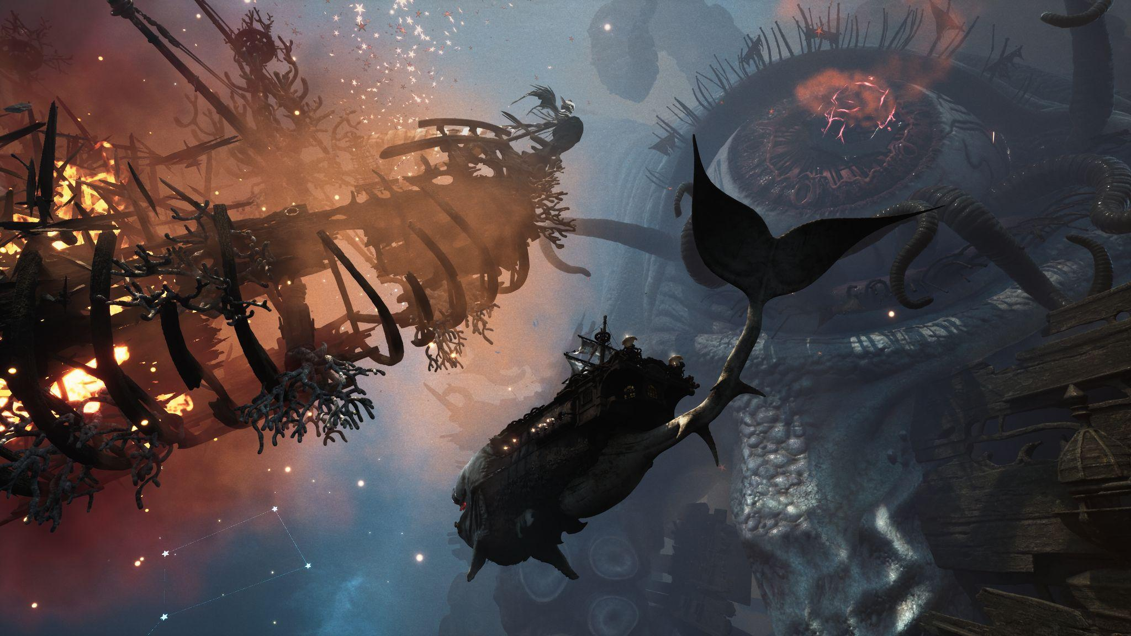
KRAKEN UPDATE — Highlights
- Be the Captain (DAVY): As Davy, you command the ship and crew. Make the tactical calls, navigate the skies, and lead your forces to victory.
- Roguelite Sky Battles: Embark on dynamic "Sky Hunts" where each run is different. Face procedurally generated encounters, adapt your strategy, and survive the storm.
- Recruit & Command Officers: Discover and recruit unique Officers, each bringing powerful, synergistic abilities to your build. Give "Orders": Make critical, on-the-fly tactical choices. These "Orders" act as run-specific perks, empowering your crew with unique abilities to turn the tide of battle.
- Hunt the Kraken: The ultimate goal of your Hunt — engage, and survive the legendary monster of the underworld, the mythical Kraken itself.
- Sky ↔ Ground Synergy: Every victory in the skies strengthens your dominion on the ground — and every defeat only feeds the storm.
“The Kraken Update finally locks the two halves into one experience. As Davy (TPP) you captain Abby in Sky Hunts—issuing Orders, growing Officers, and shaping the fight from above. Every victory in the clouds changes what you can do on the ground as Jones (FPP). What you win below powers your next hunt above. We wanted players to feel the thrill of being a legendary captain—command the ship, manage the crew, and make the tactical calls as you hunt the biggest monsters hell can throw at you.” — Bartosz Kaproń, CEO & Creative Director at PARASIGHT

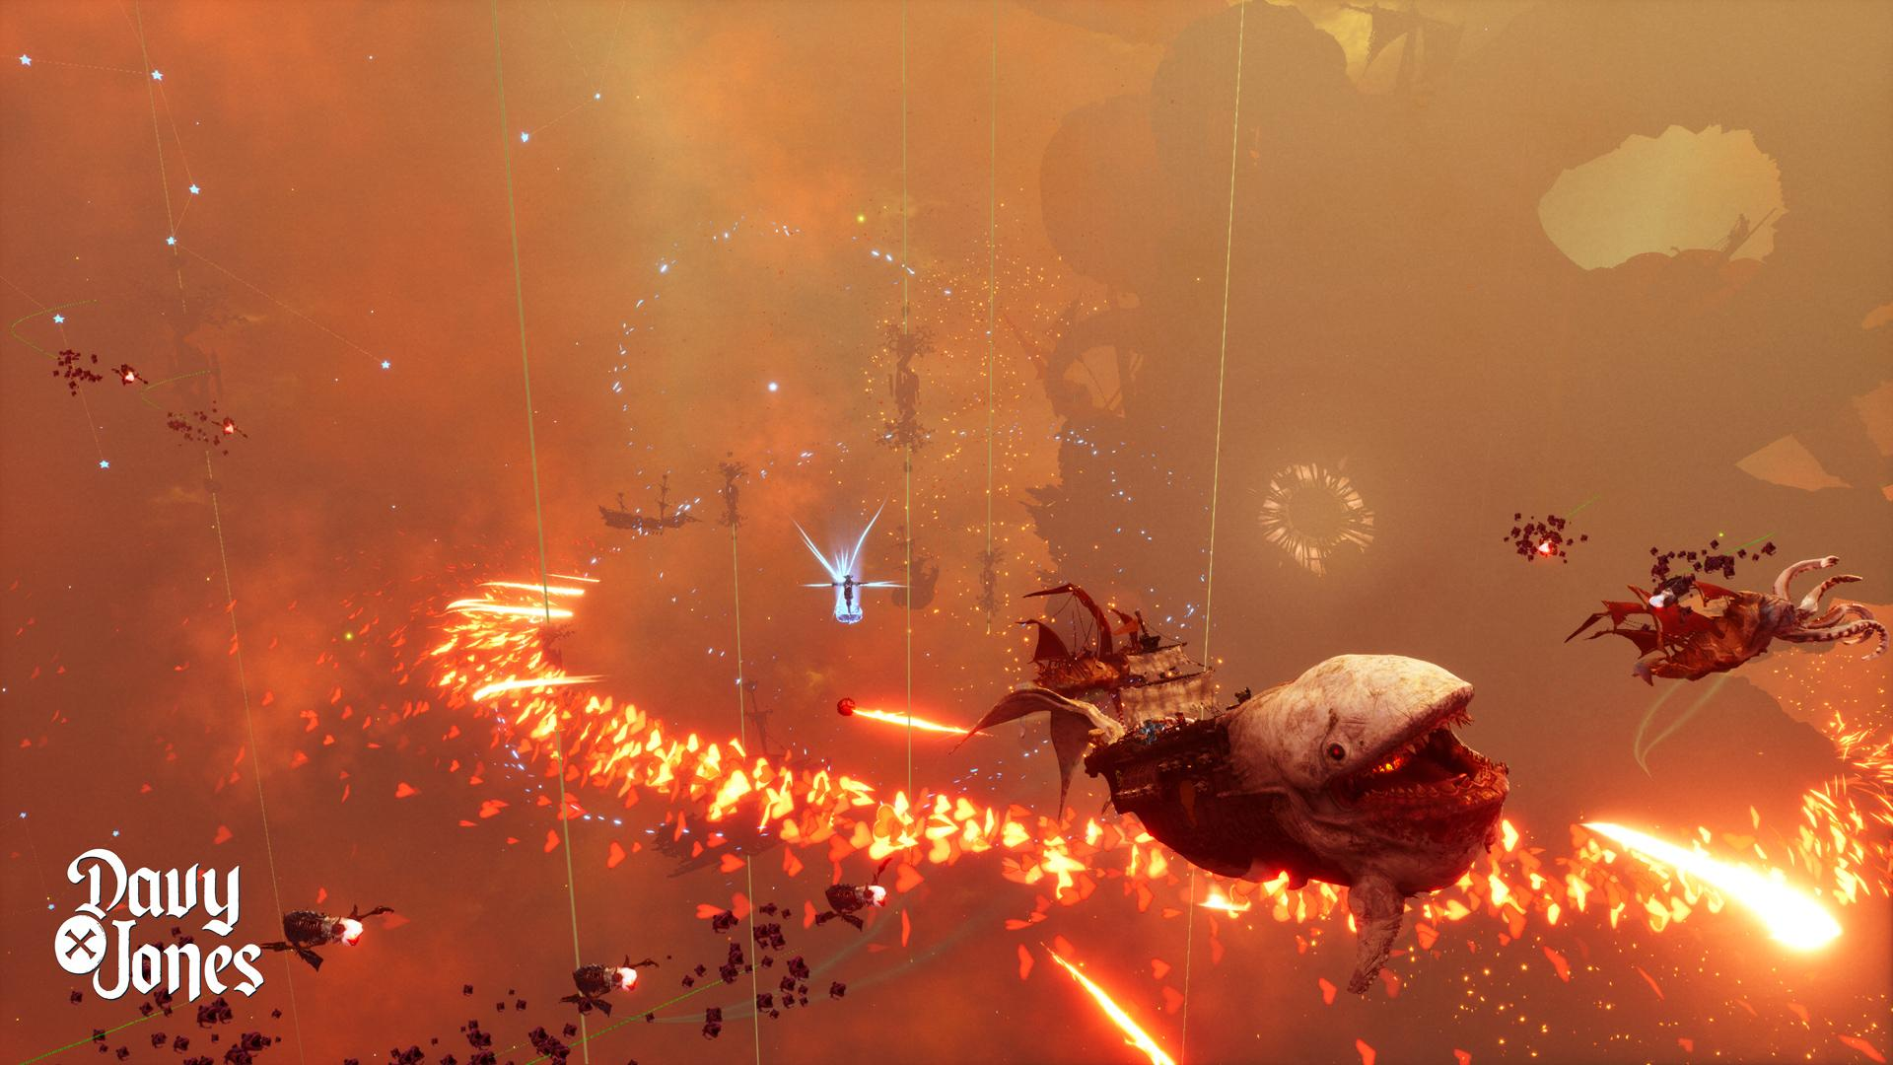

About DAVY x JONES
A grand, pirate action-adventure where you play two halves of one legendary pirate. DAVY (Head) commands the skies aboard Abby in roguelite Sky Hunts; JONES (Body) brings visceral first-person combat across the shattered isles of The Locker.
The ‘Kraken Hunt’ Update is live now. Play DAVY x JONES on Steam.
Watch the new ‘Kraken Hunt’ Update Trailer: (https://www.youtube.com/watch?v=l8ipYTh6knE).
Play DAVY x JONES on Steam: (https://store.steampowered.com/app/2611170/DAVY_x_JONES/)
Follow the game and the studio on Social Media:
- Twitter: https://x.com/DAVYxJONESgame
- Facebook: https://www.facebook.com/DAVYxJONES
- Instagram: https://www.instagram.com/parasight.studio
- Discord: https://bit.ly/DAVYxJONES_Discord

About PARASIGHT
PARASIGHT is a Kraków-based studio crafting antihero action-adventures. The team previously shipped BLACKTAIL and now builds bold, character-driven experiences with dark, playful edge.
MEDIA CONTACT: Bartosz Kaproń press@parasight.studio
