The Constructors with a demo on Steams’ Next Fest!
Creators of The Tenants show their estate building simulator!

Warszawa, Poland — February 6, 2024 — Ancient Forge, a Polish indie developer known for their very positively received landlord simulator - The Tenants, together with their publisher, Frozen District, owners of the critically acclaimed House Flipper franchise, launches a demo version on Steams’ Next Fest.
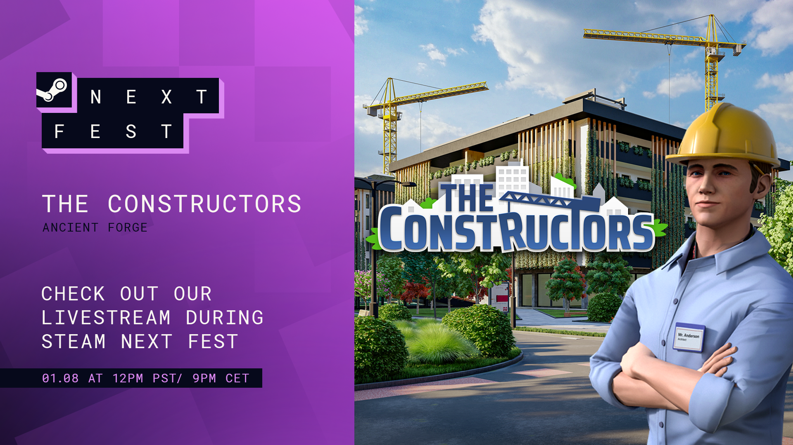
The Constructors places players in the role of a developer tasked with revitalizing Wondersville's urban landscape. As the owner of a construction company, you'll be engaged in designing new neighborhoods, fulfilling contracts to realize the vision, and managing the delicate balance between client satisfaction and maximizing profits. The game's tone is encapsulated in the challenging question: Will you play by the rules or cut corners to boost your bottom line?

Playable Demo Unveiled at Steam Next Fest

Adding to the excitement, a playable demo of The Constructors is now available as part of Steam Next Fest. This presents an excellent opportunity for gamers to experience firsthand the intricacies of construction and property management. The demo offers a taste of what's to come, allowing players to explore The Constructors and the tough life of being a developer before the full game release.

Watch the newest Devlog to learn more about the The Constructors demo!
The Constructors producer, Piotr “Majestic” Majewicz talks about the demo and developers' plans for the game in the new Devlog video. In the upcoming months, Ancient Forge will provide more information about the specific mechanics and the gameplay.
Join other Constructors on Discord, Facebook, and X, or follow our new channel on TikTok and Instagram.

About The Constructors
The Constructors is a new simulation game from the Polish developer, Ancient Forge, creators of a well-received landlord simulator, The Tenants. From landlord management to the bigger picture of renovating a neighborhood, the team behind the game uses all their simulator-based experience to provide the unique experience of being a real property developer.

About Ancient Forge
Ancient Forge is a video game development and publishing studio from Poland, founded in 2018 by Max Strzelecki and Dushan Chaciej. Led by experienced game developers with a strong passion for mechanics-heavy games, the studio specializes in premium PC games. The studio's core principle is to build games that the team themselves want to play, as showcased by the recent full release of The Tenants. https://ancientforgestudio.com/

