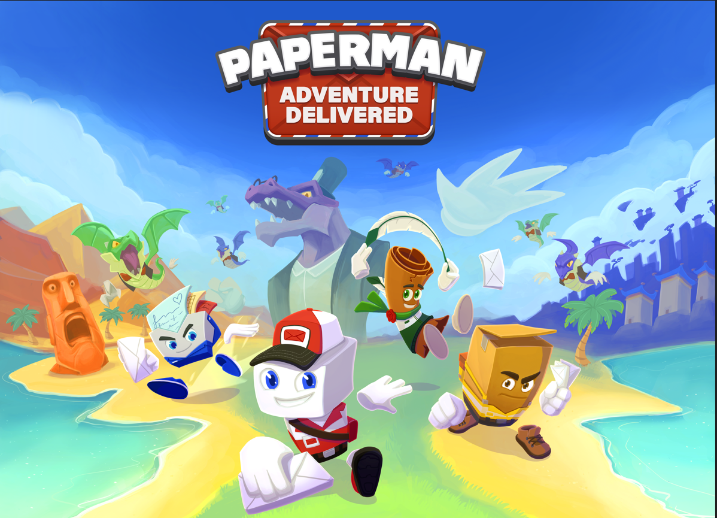

3D co-op platformer Paperman: Adventure Delivered is available now on Nintendo Switch, PlayStation 5, PlayStation 4 and PC (Steam)!
21st September 2023 Amstelveen, Dortmund
The game has been delivered simultaneously in all major territories. The digital version of Paperman: Adventure Delivered is available now on Nintendo Switch, PlayStation 5, PlayStation 4, and, PC (Steam). The physical edition of the game is available across Europe for Nintendo Switch, PlayStation 5, and PlayStation 4.
Watch the Release Date Trailer for Paperman: Adventure Delivered HERE.
Buy or wishlist the game:
Nintendo Switch
PlayStation
Steam
ABOUT PAPERMAN: ADVENTURE DELIVERED
In the 3D Platform game Paperman: Adventure Delivered, you’ll explore colorful worlds trying to find back the lost mail and defeat the greedy dragon. Play as each of the four unique mail carriers and swap between characters to unlock their unique abilities. Paperman, our titular hero, throws letters as projectiles and can teleport short distances. Express is the fastest character and takes care of the most urgent deliveries. Scrolly glides smoothly through the air with his trusty feather and can reach the highest platforms. The final member of the team is Carl, the strongest box of the bunch, he delivers the heaviest parcels with great care!
PAPERMAN: ADVENTURE DELIVERED – MAIN FEATURES
- Inspired by the classic 3D platform, collectathon games.
- Up to 4 players local co-op in split-screen (PlayStation 4 / Nintendo Switch: 2 players).
- Play with 4 charming characters, each with their own skillset:
  - Paperman the mail carrier has the ability to throw envelopes and teleport short distances.
  - Express, our runner envelope is the quickest of all four and moves at lightning speed.
  - Carl, the strongest box of the bunch has a lot of strength and has no problem moving heavier objects.
  - Scrolly, shaped like a traditional scroll, reaches different heights by gliding with this feather into cyclones or even creating small gusts of wind of his own.
- Swap characters at a moment’s notice at the mailbox.
- Fly, jump, run, teleport and push your way through the colorful worlds.
- Explore 3 open worlds with ancient temples, scorching hot deserts and mountain peaks.
- Activate hidden platforms, turn on wind tubes and solve challenging puzzles.
- Find hundreds of collectible items and collect all golden letters.

Paperman: Adventure Delivered is available now, both digitally (on PlayStation 5, PlayStation 4, Nintendo Switch, and PC (Steam) and physically across Europe (on Nintendo Switch, PlayStation 5, PlayStation 4).

Paperman: Adventure Delivered © 2023 Developed by Secret Item Games GmbH. © Secret Item Games 2023. Published by Mindscape. Mindscape® and the Mindscape® Logo are registered trademarks of Elementalz B.V. and its affiliates. ©2023 All rights reserved.

__________________________________________________________________________________
About Mindscape
Established in 1991, Mindscape has been at the forefront of development, marketing, publishing and distribution of video games for over 30 years. Capturing the minds and imagination of millions of gamers around the world, from children to adults. Mindscape is best known for Distributing big brands such as Asterix & Obelix, The Smurfs, Kena: Bridge of Spirits, Story of Seasons. Publishing games like Windstorm/Whisper, Speed 3: Grand Prix and Recompile. Developing products like Prince of Persia 3D, Myst, Riven, Reader Rabbit, Life in Willowdale: Farm Adventures, Advent Calendar, Super Puzzle Pack. In the coming years, Mindscape will bring more fun- and accessible games. For more information, visit www.mindscape.com. Mindscape® and the Mindscape® logo are registered trademarks of Elementalz B.V. and its affliates. © 2023 All rights reserved.

___________________________________________________________________________

About Secret Item Games
Secret Item Games is an indie game developer, a console porting service provider and an indie game publisher all in one. https://www.secret-item-games.com/

